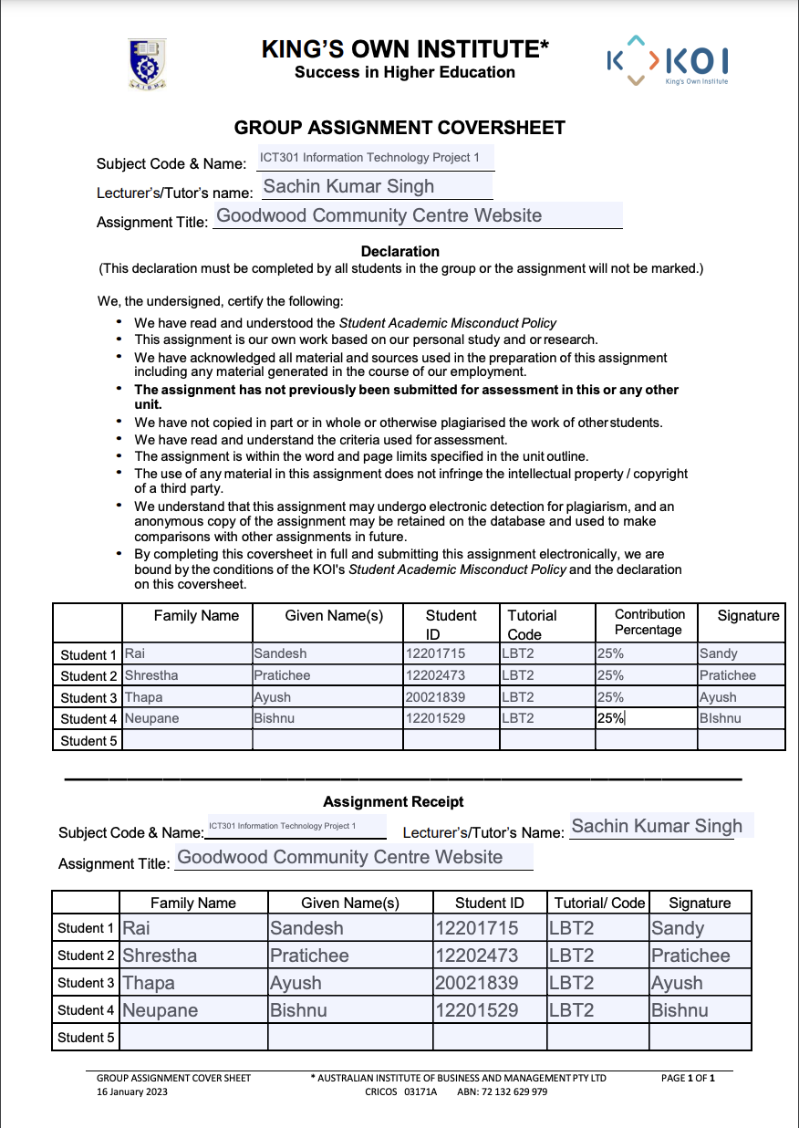

**Executive Summary**

The Goodwood Community Centre website project has been designed to provide the organization with a user-friendly and vibrant online platform that enhances community engagement through online interactions and operation. The website includes features like event calendar, venue booking system and user registration with memberships which allows them to interact with the community events and programs. This website is designed to answer the questions through pictures and collective information solving the minimum manpower problem. The website offers responsive design across different screen sizes also serves as the digital hub to promote events, provides important information and connects community members online. Streamlining the events, hall bookings and programs would provide a digital interaction between community’s member with the Community Centre, which the website will fill that gap to support the Community Centre’s mission.

Table of Contents

Introduction: 4

Context or background 4

Purpose 4

Description 4

Objective 4

Scope/Limitation 5

Limitations: 5

Literature Review: 5

a. YMCA Website (www.ymca.org ) : 5

b. City of Melbourne (www.melbourne.vic.gov.au) : 6

Summary: 6

Technology Review For Website Development: 7

a. Programming Language: 7

b. Front-End Frameworks: 7

c. Back-End Framework: 8

d. CMS 8

e. Database 8

Project Planning 8

a. Project design Methodology 8

b. Project Timelines 9

c. Work Breakdown Structure 12

d. Budget 13

Requirement Analysis 14

a. Functional Requirements 15

b. Non-Functional Requirements: 16

c. User Stories: 17

Design 29

a. Sitemap 29

b. User flow charts: 30

i. Use case diagram: 30

ii. Flowcharts 31

c. Entity-relationship diagram 36

User-interface design: 37

a. Low-fidelity design: 37

b. High-fidelity design 50

Conclusion: 62

Recommendation: 62

References 64

# Introduction:

## Context or background

Goodwood community Center is a non-profit organization located in Hobart and offers various services like community garden, playgroup, learn drive program, eating with friends, walking group and aims to bring a sense of belonging to various groups of people within the community. With limited staff and funding, creating the website for the organization would minimize administrative workload, ease the booking of services, and engage more community involvement. This website supports and mission of Goodwood Community: to connect, learn, grow, and share together.

## Purpose

The project is focused to design and develop a complete digital platform that improve service capacity of the Goodwood Community services by enhancing the interaction, connection, support, and engagement with the community. To facilitate service access, increase operational effectiveness, and reduce the staff workload. Moreover, this project will develop a user-friendly and easily navigable web application that aims to allow users to independently book services, access program information and submit enquires online. The web app will focus on developing interactive design and digital experiences that will value the mission and vision of the company. In addition, platform will be working as a central hub of information about events and programs. Using the various features like online reservation and booking, calendar, language translator, chatbot, membership and payment integration will help the vision of the company.

## Description

One of the local community center located in Hobar, Goodwood Community Center is looking for fully functional web application to establish lively and encouraging environment where everyone in the community feels welcomed and empowered. Their main scope is to improve community engagement through a user-centric design and innovative features. The project will work on improving user experience as web app acts a central hub oof information about the program, schedules, bookings, and community interaction. It is going to have a basic search functionality and basic analytics where the admin can track the user visits, page views, etc. The project will operate in two phases where the first phase includes creating the initial design concepts focusing on user experience and interface design and developing a working prototype to demonstrate key functionalities. While the second phase includes the completion of the web app based on the prototype, perform comprehensive testing to ensure reliability, performance, and compliance with requirements and integrate into the client’s operational environment. After its completion the company will have a fully functional web app where they can reach a broader audience in the community, reduce the administrative workload, and facilitate easy, self-service access for users.

## Objective

Objectives of the web application of the Goodwood community center are mentioned below:

* To develop a web application that has various functionalities like: booking, events, program, membership.
* To design a user-friendly web application and which is easy to use and navigate.
* To create a booking system where community member and guest for can reserve for different events and halls.
* To track user behavior like page visit, user interaction and insights.
* To integrate with community existing Facebook account and share the events, post, and photos.
* To create a chatbot to answer the frequently asked questions and ease the workload of staff.
* To add language translator to translate commonly used language in community.

## Scope/Limitation

Scope is mentioned below:

The web application created under this project should be fully functional and have following functions:

* Events and hall booking: The booking facility for halls, events, or programs.
* Analytics: It should do basic tracking of visitor counts, page views, and visitor interaction.
* Accessibility: The website should make the Centre accessible to people in the community to check in on services and reservation.
* Mobile Responsiveness: The design elements should be responsive on tablets, phones, and desktops.
* Content Management: Admin should easily upload, and edit videos, post, photos.

## Limitations:

* Budget Constraint: As, Goodwood Community Center is a non-profit organization, features should be affordable.
* No full-time staff: The system need to user friendly and handle the regular question using web app as company does not have staff for that.
* Mobile Responsiveness: The design elements should be responsive on tablets, phones, and desktops.

# Literature Review:

The similar website like YMCA website, City of Melbourne, Community Garden Australia have been compared and review below:

## YMCA Website ([www.ymca.org](http://www.ymca.org) ) :

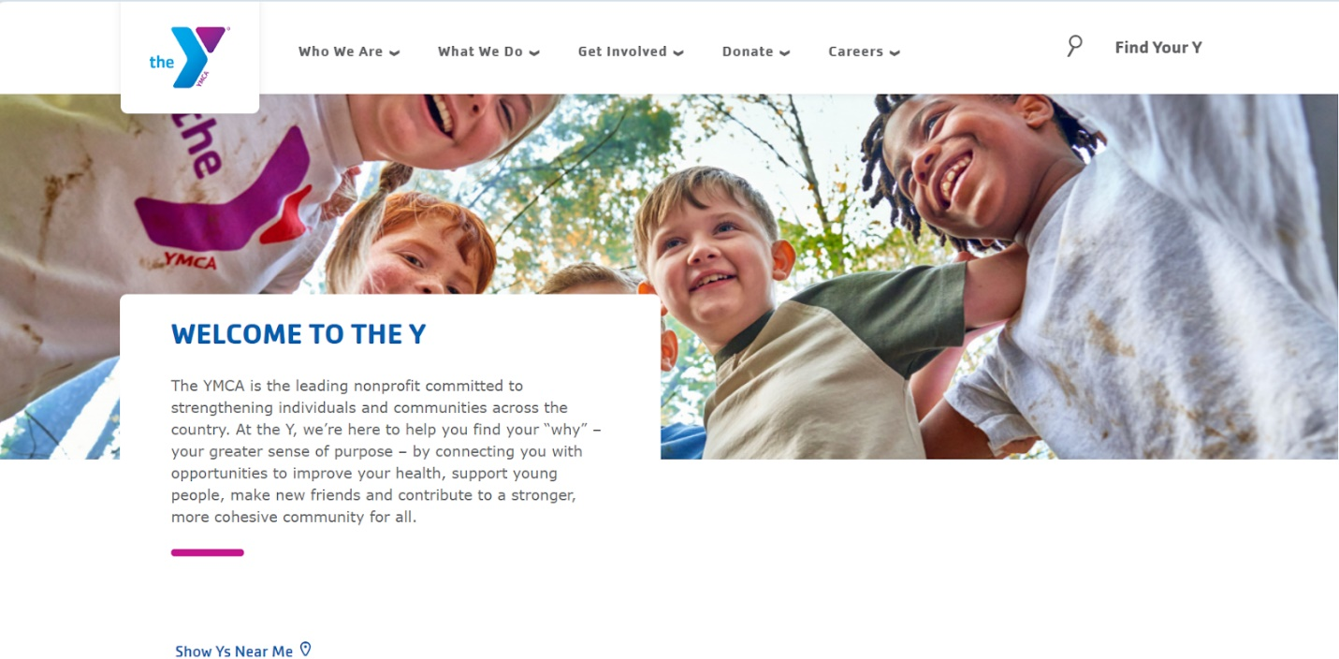

## City of Melbourne ([www.melbourne.vic.gov.au](http://www.melbourne.vic.gov.au)) (Melbourne, n.d):

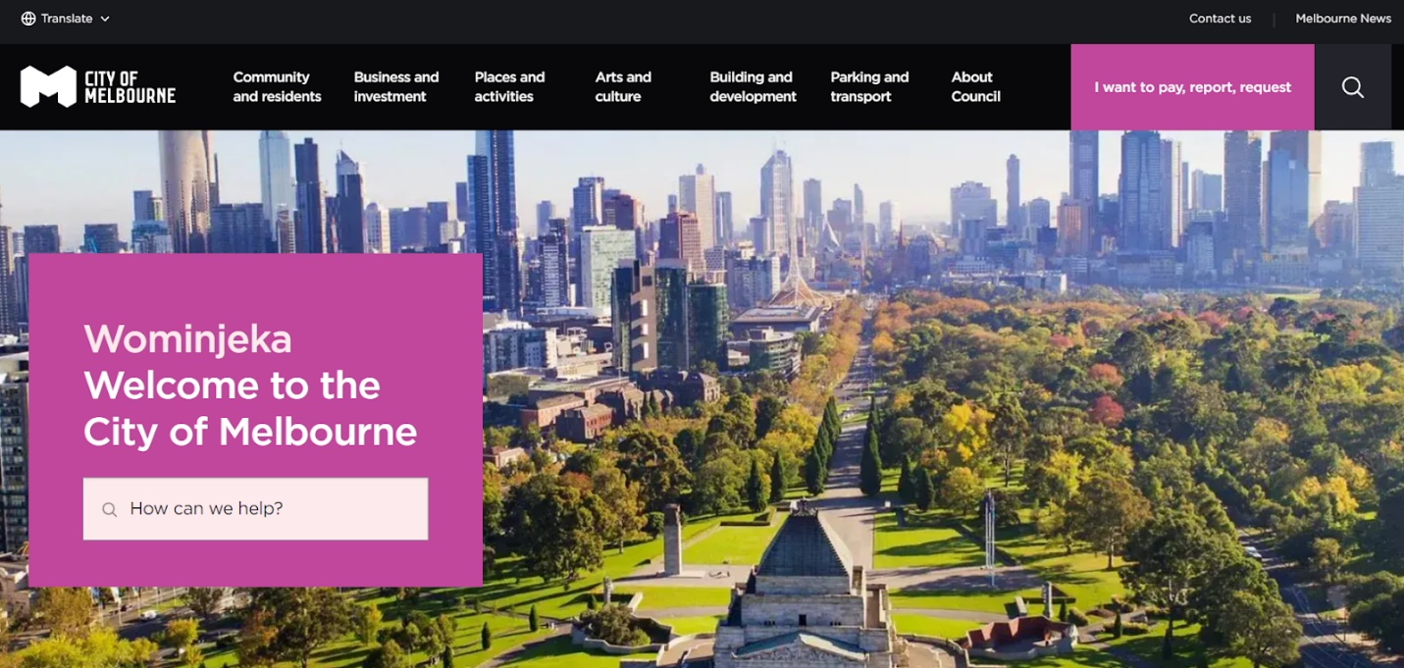

1. **Community Garden Australia(<https://communitygarden.org.au> )** (Garden, n.d)

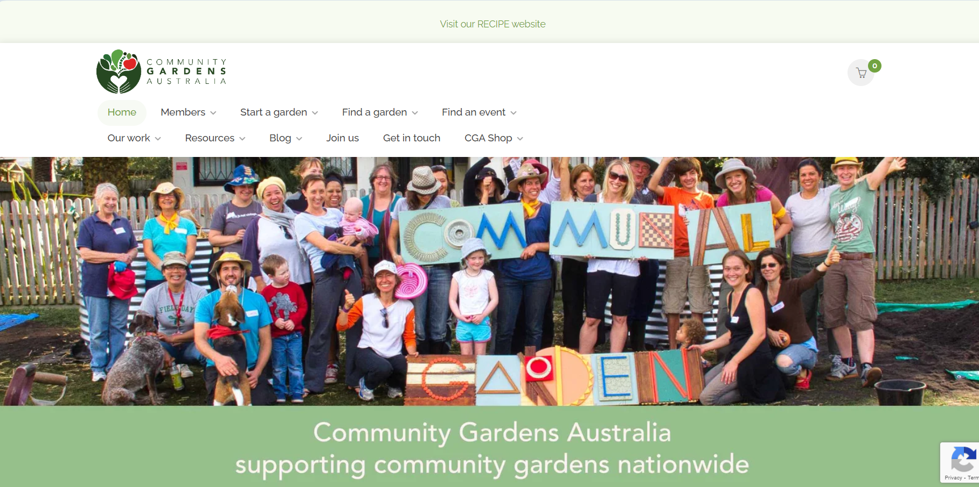

## Summary:

All the above website YMCA, City of Melbourne, and Community Garden Australia provides the various details about the community, search functionality (YMCA, n.d). Some of the features match with the requirements of the Goodwood website and others don’t. We have compared the features of those website below:

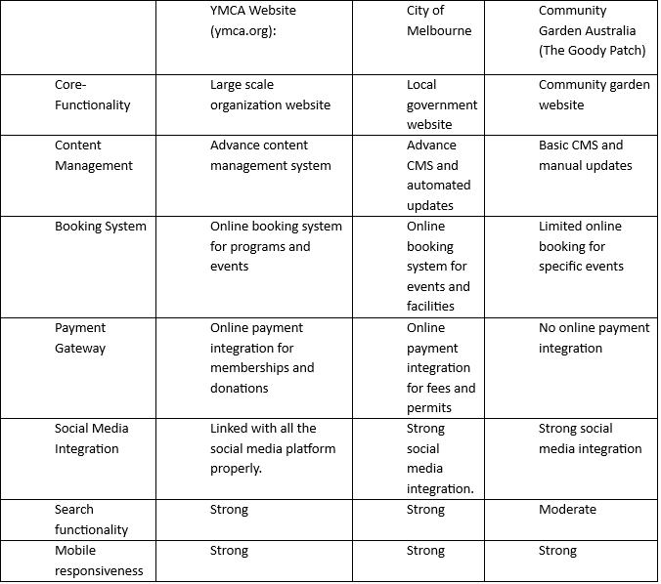

# Technology Review for Website Development:

Various tools, frameworks, and technologies have been reviewed to match the project requirements and get the best result of website of Goodwood Community Centre website. Below comparison among technologies are mentioned:

## Programming Language:

JavaScript: JavaScript is modern and friendly web development tool supported by all browsers and integrates with modern frameworks like React and is also compatible with other languages (Dionne, 2022).

Html and CSS: It is important for the structure and style of the website.

## Front-End Frameworks:

Frameworks like React and Bootstrap is popular but react is highly flexible, more efficient while designing complex UI. Also, react has flexible library for JavaScript for building UI.

## Back-End Framework:

Framework like Django(python), Node.js, Express.js are highly used. Django is framework that has built in admin panels and enable rapid and safe development of websites. Express.js is good for particularly back-end service which is small. But the Node.js has high level performance with JavaScript and create fast and scalable backend architecture (Kramer, 2024). Also, it gives access to many libraries which will help in development.

## CMS

Content Management System helps to create a website or content in internet with less knowledge and tools like WIX and WordPress are the example. In the project if we need to use CMS, then WordPress will be used as its easy and convenient for staff to use platform.

## Database

PostgreSQL, MongoDB, SQLite are the software which can be used for database. But looking after the ease and compatibility of the software, MySQL would be used for database. Because of the features like simplicity, high speed, easy set up and compatibility for large communities, MySQL will be used in the project.

# Project Planning

To ensure the success of the website for Goodwood Community centre, effective project planning is crucial. This report describes the structured methodology followed to implement the project, including the design methodology, timeline, work breakdown structure and budget. The design and planning stages address usability, scalability, and security need to provide a suitable platform for all the stakeholders involved.

1. Project design Methodology

This project uses an iterative, holistic approach to designing, as well as the best practices to lead to its outcome meeting user and organization goals (Narasimman, 2017). The main stages of these methodology are:

1. Requirements Analysis: This project designed and executed a requirement analysis process comprising stakeholder interviews, competitor website analysis and documentation review to determine critical features and functionalities.
2. Design and Prototyping: Creating mock-ups and prototypes with Figma and Wix that depict the interface and navigation flow of the website.
3. Technology Choice: Choosing tools like React.js for front-end, Node.js for backend and MongoDB as the database to ensure that it is scabble and performant.
4. Development and Testing: Writing the features, and then testing it thoroughly to catch any bugs or usability issues.
5. Iterative Steps: Deploying the website on platforms such as Netlify, collecting user feedback and refining the site accordingly.

With this methodical approach, all stages of the project are completed systematically adjusting according to feedback and changing demands.

## Project Timelines

The timeline of the project is arranged in a manner to deliver on time without compromising of the quality. The estimated timeframe for each phase is as follows:

* Requirement Gathering (Week 1): Understanding what users need, what are the core components needed and what would be the environment constraints.
* Week 1: Technical Feasibility Study — Analysing if technologies like React make sense. js, Node. js, and CMS platforms.
* Design Phase (W2-W3): Prototyping (Wireframes, User Flows, DB schemas)
* Development Phase (4-7 Weeks): Front-End and Back-End and Database functionalities will be implemented.
* Week 8-9: Update contract for unit testing, integration testing, and verification of accessibility compliance
* Deployment Phase (Week 10): Rolling out the website, equipping administrative staff to effectively use the CMS and manage the calendar.
* The timeline for the project helps ensure that the deliverables are also done in a logical sequence and allow for necessary weeks.

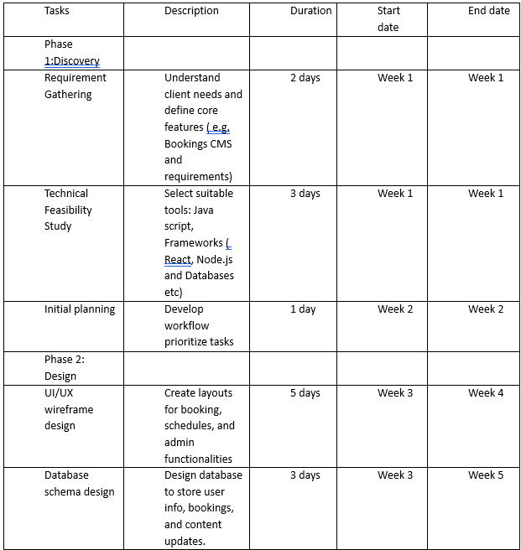

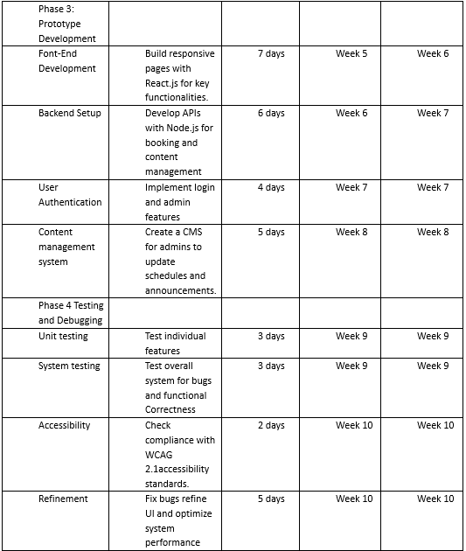

Fig: Gant Chart

## Work Breakdown Structure

The project is divided into fine-grained tasks to facilitate successful implementation of the project making us easier to plan and track the project through the below WBS:

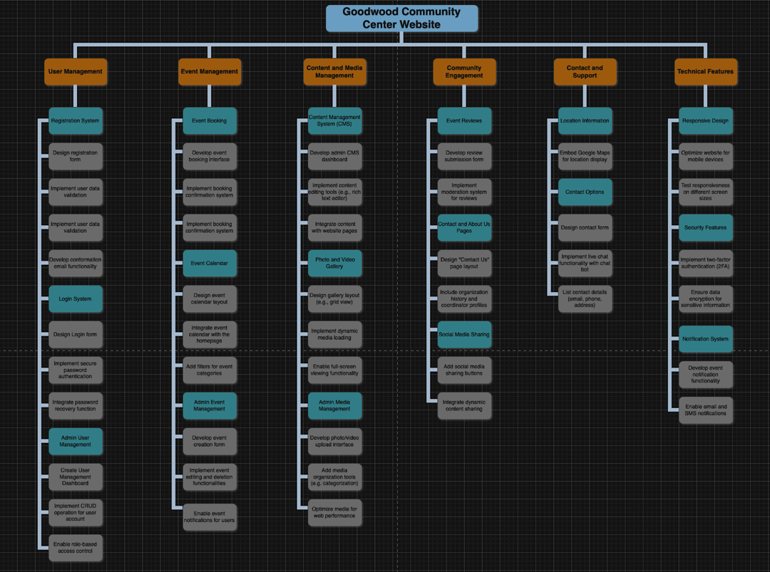

Fig: Work breakdown Structure

## Budget

As the Goodwood community centre is a non-profit organization, this whole project has been decided to create in lowest cost as possible. The project budget has been meticulously planned to utilize cost-effective solutions, with meeting all the requirements Below is the estimated budget:

Total Estimated Cost: This whole project has been created with the use of free or low-cost tools ensures affordability, particularly for non-profit organisations like the Goodwood Community Centre.

# Requirement Analysis

The project ends begin with requirement analysis, where the user needs and technical requirements are identified. The functional and non-functional requirements as well the personas for the Goodwood Community Centre website are overviewed in this chapter. Addressing these necessities guarantees the provisions of a complete platform to meet the goals of stakeholders.

4.1. Requirement Gathering:

These requirements were collected using studied analysis and stakeholder involvement that concentrated on functionality and user engagement. The highlight of the following key points:

1. General Information

* To make sure that the website suited its main users well, the following questions guided the requirements gathering process.
* Who are the main users of the website? The site’s readership includes community members, volunteers and administrators.

1. Homepage Design:

* What kind of content will be shown on the homepage like upcoming events, announcements, or featured stories? Covid-19 “Yes, you will have them to showcase on the front page.

1. Event Management:

* Online event registration and whether to show that to users. Yes, part of that core feature is registration to the event being seamless.
* Is calendar system integration a requirement for you? Yes, for clear display of event listings.

1. Volunteer Opportunities:

* Would you like a section for volunteers to register or see opportunities? Yes, this will match volunteers to appropriate roles.

1. Content Sharing:

* Do we need the ability for users to share website content directly to their social accounts? Yes, for further extension of community.

1. Multimedia Features:

* Are there areas for event photos or videos to be highlighted? And yes, galleries will put a spotlight on past and forthcoming events.

1. Notifications and Updates:

* Should the website alert users of updates or upcoming events? Yes, through email or MM notifications.

1. Design and Branding

* Does the organization already have branding (logos, color schemes, fonts) created? You will incorporate those to be in line with their identity.
* Inspirational References:
* Are there certain websites you think are designed or function well? Examples were provided by stakeholders that helped guide design.

1. Content Management

* Content management: Core to ensure website remaining updated:
* CMS Requirements: You need a Content Management System Yes, for easy updates.
* Responsibility: By whom is content being updated? The organization’s own administrators will.
* How frequently will you need updates? Weekly, or as needed.
* How many images you want on one page? Each page of galleries will display up to 10 images to load them quickly.

1. Forms and Functionality

* Features of the websiteTo make the website more interactive, it will have: Types of Forms:
* Please note: All form types such as contact forms, volunteer signup forms, feedback forms, event registration forms.

1. Authentication:

* Is two-factor authentication offered at login? Yes, for enhanced security.
* Spam Prevention:
* Should CAPTCHA or similar tools be used on forms? Yes, for the purpose of preventing spam submissions.

1. Technical Requirements

* To perform well and be accessible:
* Cross-Device Compatibility:
* Do you think the website needs to be mobile, tablets, and desktops compatible? Yes — for a consistent experience across devices.
* Performance Metrics: We will prioritize fast load times, secure connections, and intuitive navigation.

## Functional Requirements

Fictional requirements are based on what system should do. This includes things like user registration, event booking, and content management. Functional requirements define specific actions that the system should take or responses that it should produce to ensure that the

1. User management:

* Users can signup on the website and become members of the organization.
* Members can make bookings for events and create reviews and can view them by login of website.
* Admin can also able to manage user accounts (i.e., update, approve, edit, and delete).

1. Content Management

* Admin can create pages of the website.
* Existing pages can be edited and managed by admin.
* The content should be classified into different sections.
* Admin can Attach images & videos with event pages. Users can share photos and videos of previous events.
* Admin can add documents and resources downloadable for the users.

1. Event and Calendar Management

* We will have to integrate Calendar in a Webpage to view the Events.
* Users can filter events by date, type, or location.
* Users will be able to book event or hall slots online.
* Admins control and update the calendar to prevent conflicting appointments.

1. Information Management for Organizations

* The web app displays the organization’s history and mission to give indicative information about the organization.
* Team Profile of the webapp (with their photos and description)
* Admins would be able to edit the “About Us” part.

1. Payment and Membership Management

* members should be able to buy paid memberships for additional benefits.
* The users should be able to pay the payments for the hall rentals in a secure manner. Payments are accounted for on the admin side. Payment Receipts
* Payees needs to send Receipts to Users whenever a transaction was made successfully. Secure payments via Paypal or credit cards.
* Admin should be able to track and manage all payments.
* The system shows a breakdown of user’s payment details.

1. Search Functionality

* The web app allows users to search events by some keywords.
* Through the system, users can search the resources by topics.
* Admin sees popular search queries for insights.
* Media and Survey Management

1. Media management

* Users can publish events in social media channels.
* Someone can add a sharing button to event pages.
* Users can submit surveys online. Admin can create and publish surveys and questionnaire for users.
* Admin processes the surveys/questionnaires.

1. Analytics and Reporting

* The system should be able to keep count of the number of users visiting the website.
* Admin should be able to track and report the number of registrations.

## Non-Functional Requirements:

These define the way a system offers its capabilities. These include things like security, scalability, performance, and usability. These requirements have become increasingly important to deliver seamless user experience and enable future scaling.

1. Page loading time must be at most 3 seconds.
2. User data must be stored securely with encryption.
3. HTTPS must be used for all communication.
4. Navigation must have consistent menus and buttons and it must be intuitive.
5. There should be scalability in the system to add and support features or increase user load.
6. The database must handle growth in the number of events, users, and bookings.
7. Backups must be performed daily to ensure data recovery in case of failure.
8. The system must be compatible with all the modern browsers.
9. The system must be able to work effortlessly on all the platforms.
10. The system must support multi-language content.
11. Report must be generated within 5 seconds of the query.

## **User Stories**:

As we know, user stories are descriptions of a feature or requirement, which is written from the perspective of endure, in short and simply. It is crucial for understanding user needs and prioritizing functionalities.

Types of Users in GoodWood Community Center website:

1. Guest Users: general visitors.
2. Registered Users: registered account on the website.

Paid Members: purchased memberships. Types of Users in GoodWood Community Centre website:

1. Guest Users: general visitors.
2. Registered Users: registered account on the website.
3. Paid Members: purchased memberships.

As every functionality given to a user is allowed to any type of users, hence we will call them users for the user stories.

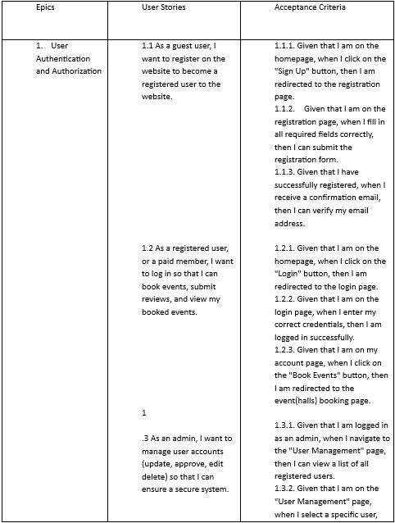

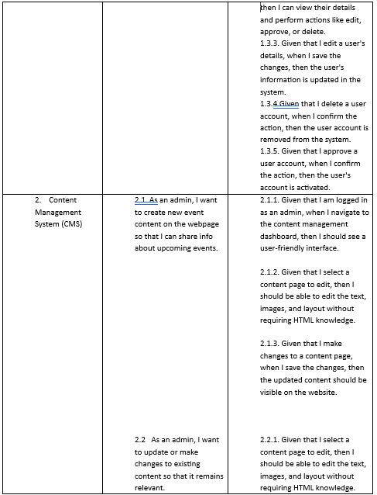

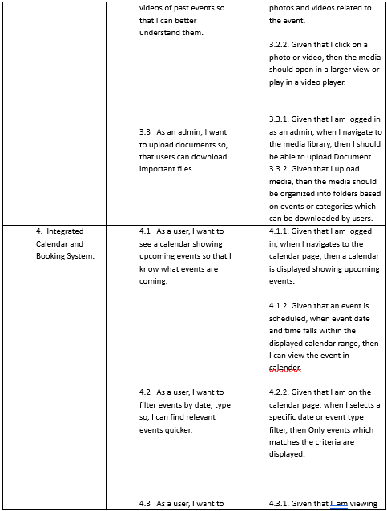

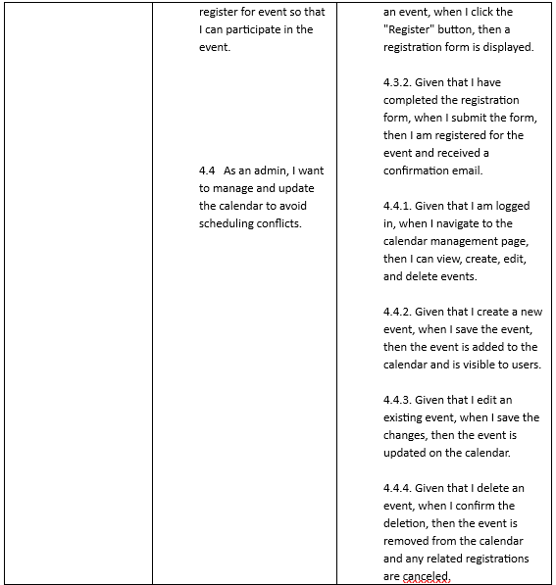

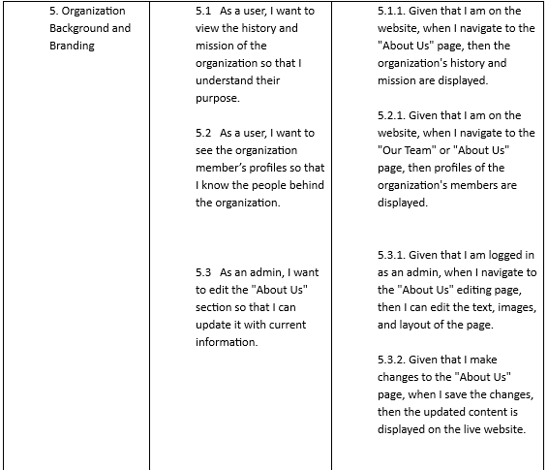

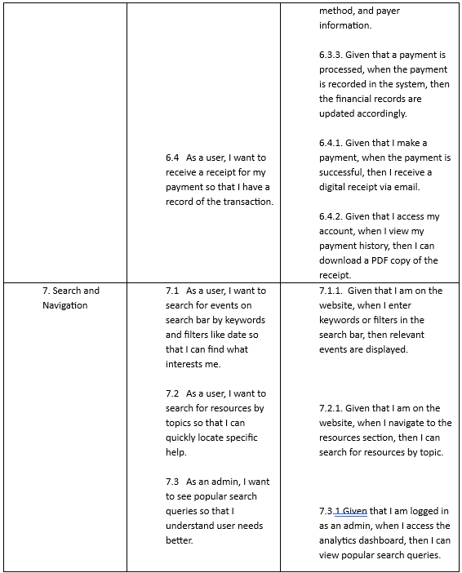

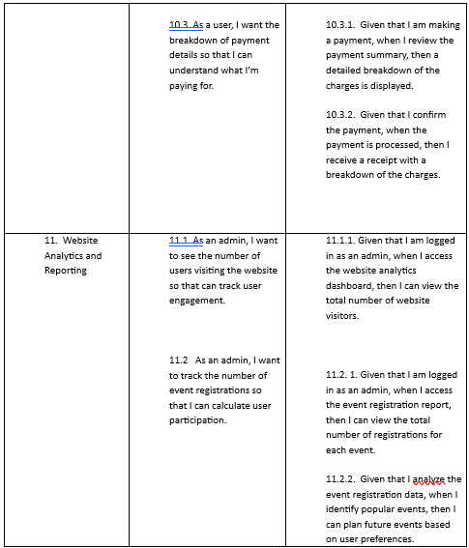

# Design

## Sitemap

Based on the requirements gathered from the client, we have prepared the site map for the web app for the Goodwood community centre:

Fig: Site map of the website

## User flow charts:

* 1. Use case diagram: We have used case diagram to represent the interactions between the user (external systems) and the Goodwood Community Centre web app. We have a total of 6 different actors(users) who interact with the web app in different way. They can be seen in the following use case diagram:

Fig: use case diagram with actors and functions

* 1. Flowcharts: We used flowcharts to illustrate the complex processes in the web app to make it easier to understand and communicate. We can see the flowchart below:

Fig: Flowchart for user authentication and Login

Fig: Flowchart for registering for an event

Fig: Flowchart for booking a venue.

Fig: flowchart for becoming a member

## Entity-relationship diagram

Fig: ERD Diagram for Goodwood Community website

Relationships between these entities

* Registered User/Guest User can participate in multiple programs and a program can have multiple participants.

Registered User/Guest User → Participation → Program: Many-to-Many

* Registered User/Guest User can participate in multiple events and an event can have multiple participants.

Registered User/Guest User → Participation → Event: Many-to-Many

* Registered User/Guest User can hire one or multiple venues and venues will be hired by one user.

User/Guest → Booking Form: One-to-Many

* Each participation has individual payment, and each payment belongs to a certain participation. One-to-One.

* Each membership has individual payment, and each membership pays their certain membership-fee. One-to-One.

* Each venue booking has individual payment, and each payment is done to book the venue. One-to-One.

## User-interface design:

Based on the client’s requirements we have designed a low-fidelity design followed by a high-fidelity design. Then we designed the prototype based on those designs. Snapshots of low-fidelity and high-fidelity design can be seen below with the link to the prototype of the website:

### Low-fidelity design:

Fig: Low fidelity design of Home page of the website

Fig: Low fidelity design of about us page

Fig: Low fidelity design of blog post page

Fig: Low fidelity design of contact us page

Fig: Low fidelity design of contact us page

Fig: Low fidelity design of what we do page

Fig: Low fidelity design of events page

Fig: Low fidelity design of event description page

Fig: Low fidelity design of sign-up page

Fig: Low fidelity design of log in page

Fig: Low fidelity design of gallery page

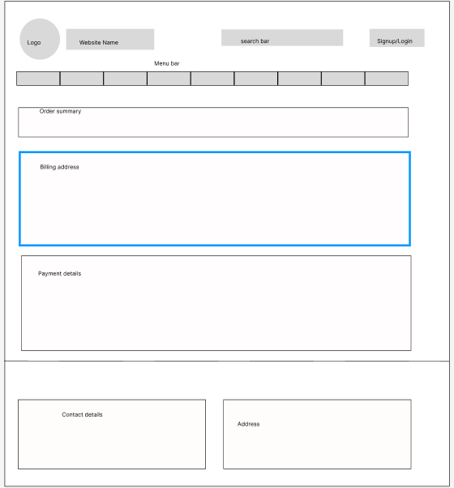

Fig: Payment page Low fidelity design

Fig: Booking description low fidelity design

### High-fidelity design (Figma, n.d.)

Fig: High fidelity home page design

Fig: High fidelity about us page design

Fig: High fidelity event page design

Fig: High fidelity event description page design

Fig: High fidelity payment page design

Fig: High fidelity blog page design

Fig: High fidelity design of blog post page

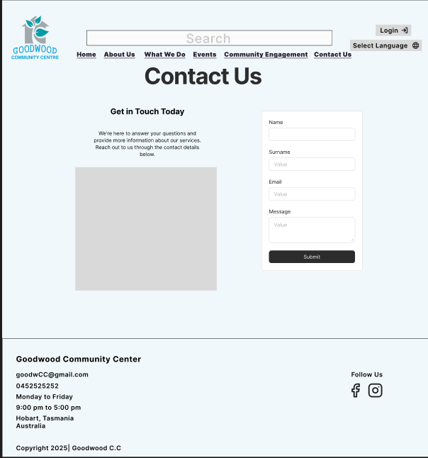  
Fig: High fidelity design of contact us page

Fig: High fidelity design of hall hiring

Fig: High-fidelity design of booking description page details

Fig: High fidelity design of gallery page

Fig: log in page high fidelity design

Fig: High-fidelity sign-up page design

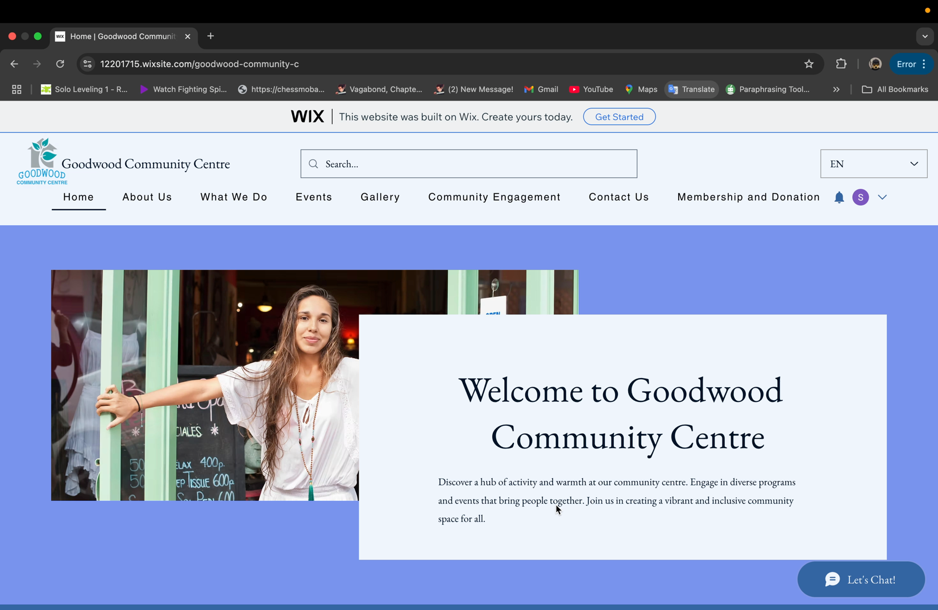

This is a video demonstration, please press play.

Prototype link:  
<https://www.figma.com/design/02cnoFBpYA9qGRBmiCPn8T/Goodwood-Community-Canter?node-id=36-3&t=aoBUsS49wnJCVsmQ-0> (High-fidelity)

<https://12201715.wixsite.com/goodwood-community-c> (Prototype)

# Conclusion:

# To conclude, report illustrated about functional web application of Goodwood Community Centre. The web app worked as a central hub of information of programs, services, events, and bookings. Community members and visitors can check for upcoming events, book halls and events, get a membership, and donate online. There will be the integration of social media with web app to share post, and the features like chatbot. Different website had been compared like Goodwood and took recommendation. Technology like: JavaScript, Html, CSS, Node.js, React.js will be used. Various chart and diagrams are used to illustrate design. Requirements are gathered through the meeting with clients and user stories, user acceptance criteria are mentioned. Low fidelity design and high fidelity are included. Final prototype is created, and link is provided in the report. Appendices:

## Group Activity Log and Contribution

#### First Meeting Minutes – Goodwood Community Centre web app

**Location:** Zoom meeting

**Date:** 6-Nov, 2024

**Time:** 4:pm-4:15pm

#### Attendance

#### Natham Reynolds(client), Ayush Thapa, Pratichee Shrestha, Bishnu Neupane, Sandesh Rai(leader) Discussion of Agenda Items

1. Introduction
2. Present proposal
3. Discuss on payment gateways.
4. Services provided by the Goodwood Community Service Center

#### Action Items

|  |  |  |  |
| --- | --- | --- | --- |
| Item Description | Responsible | Due Date | Status |
| Literature review | Pratichee Shrestha | 18 Nov | Finished |
| Technology review | Bishnu Neupane | 18Nov | Finished |
| Budget breakdown | Ayush Thapa | 18Nov | Finished |
| Timeline table | Sandesh Rai | 18Nov | Finished |

#### Other Notes

Other important details discussed during the meeting can be entered here.

1. Presented the idea about domain name and payment plan.
2. Presented the review of similar websites.
3. We presented the technologies and methodologies we will use throughout the project.
4. We discussed the project budget and timeline for different phases of the project.

#### Next Meeting

**Location:** Zoom meetings

**Date:** 19 November,2024

**Time:** 1:00pm-1:30pm

## Group Activity Log and Contribution

#### Second Meeting Minutes – Goodwood Community Centre web app

**Location:** Zoom meeting

**Date:** 19-Nov, 2024

**Time:** 1:00pm-1:30pm

#### Attendance

#### Natham Reynolds(client), Ayush Thapa, Pratichee Shrestha, Bishnu Neupane, Sandesh Rai(leader) Discussion of Agenda Items

#### Present the work done before.

1. Requirement gathering of the web app.

#### Action Items

|  |  |  |  |
| --- | --- | --- | --- |
| Item Description | Responsible | Due Date | Status |
| User stories | Pratichee Shrestha | 8dec | Finished |
| Acceptance criteria | Bishnu Neupane | 8dec | Finished |
| Functional & Non-functional requirements | Ayush Thapa | 8dec | Finished |
| Use case + sitemap + Work Breakdown Structure | Sandesh Rai | 8dec | Finished |

#### Other Notes

1. Discussed requirements for the web apps
2. Went in more detail of the clients requirements and the services provided by the community center.

#### Next Meeting

**Location:** Zoom meetings

**Date:** 10december,2024

**Time:** 1:00pm-1:30pm

## Group Activity Log and Contribution

#### Third Meeting Minutes – Goodwood Community Centre web app

**Location:** Zoom meeting

**Date:** 10dec, 2024

**Time:** 1:00pm-1:30pm

#### Attendance

#### Natham Reynolds(client), Ayush Thapa, Pratichee Shrestha, Bishnu Neupane, Sandesh Rai(leader) Discussion of Agenda Items

1. Present flowcharts and database designs
2. Present a simple prototype.

#### Action Items

|  |  |  |  |
| --- | --- | --- | --- |
| Item Description | Responsible | Due Date | Status |
| Report+ design+ prototype | Pratichee Shrestha | 26jan | Finished |
| Report + design+ prototype | Bishnu Neupane | 26jan | Finished |
| Report + design+ prototype | Ayush Thapa | 26jan | Finished |
| Report + design+ prototype | Sandesh Rai | 26jan | Finished |

#### Other Notes

1. Discussed the final design the clients want.
2. Showed the simple unfinished prototype and discussed the changes to be made.

#### Next Meeting

**Location:** Zoom meetings

**Date:** 28 Januaryr,2024

**Time:** 1:00pm-1:30pm

## Group Activity Log and Contribution

#### Fourth Meeting Minutes - [Project Name]

**Location:** Zoom meetings

**Date:** 28January, 2025

**Time:** 12:00pm -12:30pm

#### Attendance

#### Natham Reynolds(client), Ayush Thapa, Pratichee Shrestha, Bishnu Neupane, Sandesh Rai(leader)

#### Discussion of Agenda Items

1. Present final prototype

#### Action Items

|  |  |  |  |
| --- | --- | --- | --- |
| Item Description | Responsible | Due Date | Status |
| presentation | Pratichee Shrestha | - | Finished |
| Presentation | Bishnu Neupane | - | Finished |
| Presentation | Ayush Thapa | - | Finished |
| presentation | Sandesh Rai | - | Finished |

#### Other Notes

#### Presented the final prototype and the design processes.

1. Discussed clients' views and necessary changed that needs to be changed during the development phase.

# **Recommendation:**

* Develop the web app in a user-centred approach to cater a diverse range of users including those who are not used to technology.
* Ensure protection of data by enforcing HTTPS, encryption of secret data and use authentication methods like multi-factor authentication.
* Ensure fast content delivery by reduction of loading time by optimizing images, scripts and using caching solutions.
* Ensure scalability of web app by using cloud services as user demands grow.
* Prioritize a responsive design so the site can be accessed on any device in any screen size.

# References

Dionne, M., 2022. *Reasons Why JavaScript is Omnipresent in Modern Development.* [Online]   
Available at: https://snipcart.com/blog/why-javascript-benefits  
[Accessed 20 1 2025].

Figma, n.d.. *Figma:Design and prototype for Teams..* [Online] Available at: https://www.figma.com   
[Accessed 18 1 2025].

Garden, C., n.d. *Community Garden Australia.* [Online] Available at: https://communitygarden.org.au  
[Accessed 15 1 2025].

Kramer, N., 2024. *Backend Frameworks List: Choosing the Right One.* [Online]   
Available at: https://daily.dev/blog/backend-frameworks-list-choosing-the-right-one#how-do-i-choose-a-backend-framework [Accessed 3 12 2024].

Melbourne, C. o., n.d. *City of Melbourne.* [Online] Available at: www.melbourne.vic.gov.au  
[Accessed 15 1 2025].

Narasimman, P., 2017. *Agile vs Traditional Project Management [Top Differences].* [Online]   
Available at: https://www.knowledgehut.com/blog/agile/agile-project-management-vs-traditional-project-management  
[Accessed 11 12 2024].

Wix, n.d. *Wix:Create a website You're Proud Of.* [Online] Available at: https://www.wix.com   
[Accessed 24 12 2024].

YMCA, n.d. *YMCA.* [Online] Available at: https://www.ymca.org  
[Accessed 15 1 2025].